

ELECTRICAL AND ELECTRONICS ENGINEERING DEPARTMENT

EE464 POWER ELECTRONICS – II

COMPLETE SIMULATION REPORT

**Halid Filiz 2304632**

**Mehmet Kılıç 2232262**

**Yunus Çay 2166148**

Contents

1. Introduction 3

2. Topology Selection 4

3. Controller IC Selection 5

4. Transformer Design 6

4.1. Limitations of Primary Inductance 8

I. tOFF(MIN) – Minimum Switch Off Time 8

II. tON(MIN) – Minimum Switch Off Time 8

III. Power Storage Capability of the Transformer 8

IV. Backup Time 9

4.2. Determination of Turns Ratio 9

4.3. Determination of the Primary Inductance 10

4.4. Core Selection 12

I. Magnetic Characteristics of Core 12

II. Shape of Core 13

III. Size of Core 13

4.5. Winding and Fill Factor 16

5. Simulations 18

6. Component Selection 27

7. Conclusion 31

8. References 32

# Introduction

In this project, we are expected to design an isolated DC-DC converter that is similar to one that is used in Tesla Model S. For this purpose, requirements are analyzed first. The designed circuit should satisfy the requirements below.

* Minimum Input Voltage: 220V
* Maximum Input Voltage: 400V
* Output Voltage: 12V
* Output Power: 100W
* Output Ripple: 4%
* Line Regulation: 3%
* Load Regulation: 3%

After assessing the requirements carefully, the design process is started. First, a suitable topology is selected by discussing the advantages or disadvantages of each topology. After determining the topology, a controller IC options are discussed and the most suitable one is selected. Circuit design process is started with controller IC and other circuit parameters are selected by considering the limitations and requirements of the controller, which are stated şn the datasheet.

After determining the circuit parameters, ideal and non ideal simulations are conducted. According to the simulation results, some changes are made and commercial products are selected for some important power components like switches, capacitors and inductances. Also, magnetic design for the transformer is started.

In this report, work done until now is represented. After taking feedback, design is going to be optimized and improved.

# Topology Selection

To design this isolated DC/DC converter, we had to start by choosing a topology that satisfied our needs. The first was that this converter had to have the input and output isolated from each other. This means that we are limited to isolated topologies. The topologies that we have considered for the design are the flyback, forward and push-pull converter topologies. There are certain advantages and disadvantages for using each of these converters.

One advantage of the flyback converter is that it uses the transformer core as an energy storage element, making an extra inductor unnecessary. This situation makes flyback is a cheaper and simpler option.

Moreover, the group members have experience with flyback converter design from their summer practices and part-time working activities, which makes the flyback converter design process much easier. Therefore, flyback converter is selected to be the primary design option for this project.

While the topologies themselves are important, we must also consider the available IC controllers on the market while making our decision since if we do not have an proper IC for our topology the design is pretty much impossible. There are certain large IC controller manufacturers that have simulation models for their ICs like Analog Devices and Texas Instruments which would make our design process much easier. Therefore, controller ic election holds a crucial role in converter design.

# Controller IC Selection

After researching the conventional controllers, some ics are determined to be possible options are their advantages and disadvantages are discussed. The first option was InnoSwitch3-EP.

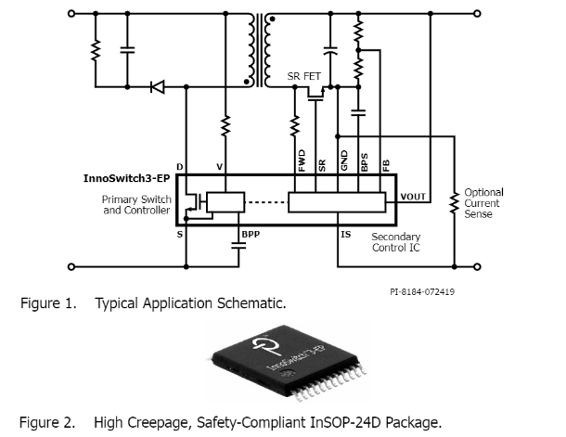

Figure 1 Alternative controller IC - InnoSwitch3-EP

This controller has an internal GaN MOSFET, which increases the switching efficiency. Also it provides synchronous drive in a single chip. According to the datasheet, no heatsink is required up to 100W. However, there is no simulation model provided for this controller and some details might be missed if it was manually modelled. Therefore, this controller is kept as a back-up plan.

Other two options are LT8316 and LTC3805 manufactured by Analog Devices. Since these devices have built-in models in LTSpice, it is logical to use ICs manufactured by AD. Both of these ICs are used for conventional Flyback Converters with the difference between them being the control and feedback mechanisms. The LTC3805 is a current mode controller with an adjustable frequency between 70kHz and 700kHz. For isolated feedback, this controller must be used in tandem with an opto-coupler driver and an opto-coupler. The advantage of this is that the load and line regulations are essentially perfect, and the frequency of the controller is constant.

The LT8316 on the other hand is a Quasi-resonant boundary operation mode controller and takes its feedback from the third wind of the transformer. The operation frequency of this controller changes depending on the load and while it has very good load and line regulation compared to other no-opto controllers, it does not give the same performance as a controller with an opto-coupler. The main advantage of the LT8316 is that it uses less parts since there is no need for an opto and also that it can be naturally started and then fed from the input and third windings. Both ICs are simulated, and it is seen that both of them satisfy the given conditions and are both suitable designs but in the end we must decide on one of them to continue with our project. Since LT8316 requires less parts, a simpler and cheaper design is possible if it is used. Therefore, LT8316 is selected as the controller of the designed circuit. Datasheets of each IC are provided in the Github repository.

# Transformer Design

Flyback converter isolates a primary side and a secondary side with a transformer. Transformer can be used to step up or down an input voltage according to turns ratio. Besides, input-output relation is the same as buck boost converter. Input-output relation is shown in Equation (1).

|  |  |  |
| --- | --- | --- |
|  |  | (1) |

Transformer is mainly used for the applications transmitting energy without storage. However, transformer of flyback converter stores an energy, and then passes it to secondary side, which is the reason for why flyback transformer is also called as coupled inductor. Hence, considerations for energy stored, saturation current, inductance are important for transformer design. The design of transformer is started with application information given in the datasheet.

Table 1 shows some system level information and controller requirements having an impact on the transformer design.

Table 1 Parameters for the transformer design

|  |  |  |
| --- | --- | --- |
| **Description** | **Symbol** | **Value** |
| Input voltage range | Vin,min - Vin,max | 220V – 400V |
| Output voltage | Vo | 12V |
| Max. output power | Pout | 100W |
| Max. switching frequency | fs | 140kHz |
| Min. Switch off time* | tOFF(MIN) | 800ns |
| Min. Switch on time* | tON(MIN) | 300ns |
| Backup time* | tBU | 50μs |

*\* These parameters will be explained in detail while calculating their limitations on primary inductance.*

Application information given in the datasheet determines the minimum and maximum limits for the primary, magnetizing, inductance due to parameters given in Table 1 such as tOFF(MIN), tON(MIN) and tBU. Before finding the limitations, the peak of the primary current should be determined according to working principle of controller and the delivered maximum output power. While the minimum current limit of the controller affects the limitations of primary inductance due to tOFF(MIN) and tON(MIN), the maximum output power has to be satisfied according to magnetic energy storage shown in Equation (2).

|  |  |  |
| --- | --- | --- |
|  |  | (2) |

The maximum peak current in primary side can be found from the desired output power. Since the peak current is observed at maximum power and the controller has boundary mode control, the peak current can be calculated as seen in Equation (3). Efficiency is taken as %80 as a safety margin due to practical considerations.

|  |  |  |
| --- | --- | --- |
|  |  | (3) |



## Limitations of Primary Inductance

### tOFF(MIN) – Minimum Switch Off Time

The feedback of the output voltage is given through the tertiary winding. The nonzero voltage between the tertiary winding is created when the secondary current flows. The required minimum time to sample voltage by the sample-and-hold error amplifier is 800ns. “*In order to ensure proper sampling, the secondary winding needs to conduct current for at least 800ns*.” [1] The limitation due to tOFF(MIN) is given in Equation (4).

|  |  |  |
| --- | --- | --- |
|  |  | (4) |

### tON(MIN) – Minimum Switch Off Time

The controller has a minimum switch on time for the sake of blanking initial switch turn-on current spike. The current, ISW(MIN), should not be reached for tON(MIN), which creates restriction on the selection of flyback transformer in terms of magnetizing inductance. The limitation due to switch on time is determined in Equation (5).

|  |  |  |
| --- | --- | --- |
|  |  | (5) |

### Power Storage Capability of the Transformer

Equation (2) shows the magnetic energy stored in an inductor for a given current and inductance. Since the flyback transformer stores magnetic energy due to working principle of flyback converter, the inductance of transformer should be able to store sufficient power. Equation (6) shows the limitation of the inductance due to magnetic energy storage.

|  |  |  |
| --- | --- | --- |
|  |  | (6) |

### Backup Time

Backup timer is stimulated to avoid low output voltage levels. Backup timer turns the primary switch on unless the secondary side diode turns off. This feature restricts the inductance value with maximum limit. Limitation of inductance of flyback transformer due to backup time can be seen in Equation (7).

|  |  |  |
| --- | --- | --- |
|  |  | (7) |

## Determination of Turns Ratio

The output voltage is lower than the input voltage level. Transformer should step down the input voltage for reasonable values so that sensitivity of duty cycle should not be high, i.e., duty cycle below %10 is problem for controllers. Therefore, the turns ratio should be high as much as possible to keep duty cycle in a range between %50 and %20.

Turns ratio has also impact on breakdown voltage of semiconductors. Table 2 shows maximum terminal voltages of the primary switch and the secondary diode. The turns ratio has reverse effect on the semiconductors. While turns ratio, N, increases reverse voltage of the primary switch, it reduces reverse voltage of the secondary diode.

Table 2 Relation between turns ratio and reverse voltage of the semiconductors

|  |  |
| --- | --- |
| **Semiconductor** | **General Formulation for Reverse Voltage** |
| Primary switch | VDS = Vin + N(Vo + VF) + VLeakage |
| Secondary diode | VR = (Vin/N) + (Vo + VF) |

The turns ratio is selected as 8, which keep the duty cycle between %20 and %30. Also, this selection can be optimized value in terms of reverse voltage of semiconductors and duty cycle. The increase in reverse voltages results in increase in switching losses and decrease in safety margin of devices. Duty cycle of the flyback converter in a range of input voltage is shown in Figure 2.

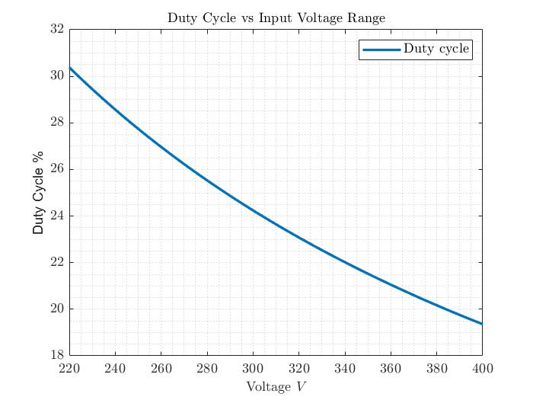

Figure 2 Duty cycle vs input voltage range for 8 turns ratio, N

## Determination of the Primary Inductance

In the part 0 , 0.16mH and 1.08mH are founded as minimum and maximum limitations, respectively. The value between the limits may probably work. However, safety margin for each limit should be determined to eliminate unexpected practical issues. The safety region for each limit can be taken as %25 of limiting value above and below for minimum and maximum limits, respectively. Hence, the primary inductance value should be between 0.2mH and 0.81mH.

The boundary mode control requires variable switching frequency according to the load. When the primary switch is on, the inductor current starts from the zero. Therefore, the frequency relation between frequency and inductance for the same input voltage and output voltage is obvious, which is shown in Equation (8). Since duty cycle and turns ratio is constant, switching frequency and primary inductance are inversely proportional for the same amount of inductor current ripple. The inductor current ripple is determined according to output power.

|  |  |  |
| --- | --- | --- |
|  |  | (8) |

Transition to DCM occurs as the load decreases. Duty cycle calculation in DCM can be seen in Equation (9). Both calculations are the same except the Pout, Vo, and R relation.

|  |  |  |
| --- | --- | --- |
|  |  | (9) |

Supply of the input power occurs during the on time of primary switch. Therefore, the current ripple of the inductor is directly related with the delivered power. Equation (10) shows the inductor current ripple calculation in DCM, which shows that Lm and fs are also inversely proportional in DCM.

|  |  |  |
| --- | --- | --- |
|  |  | (10) |

According to analysis of the relation between Lm and fs, increase in Lm results in low switching frequency, hence, low switching loss. On the other hand, boundary mode and DCM eliminate turn-on loss of the primary switch and reverse recovery of the secondary diode. Even if the increase in Lm can be beneficial for switching losses, the tradeoff due to increase in Lm is increase in size of flyback transformer and increase in windings, which causes more copper and core losses. The question that there is a relation between copper, core losses and frequency. Actually, this type of relations are the signs of need in optimization.

After considering iterative relation between Lm and fs, the Lm, primary inductance, is chosen as 0.4mH.

## Core Selection

Core selection is based on shape of a core, size of a core and magnetic characteristics of a core. First, selection based on magnetic characteristics of a core is analyzed.

### Magnetic Characteristics of Core

General approach for the selection of core type is divided into two for flyback transformer; distributed air-gap powder cores and gapped ferrite cores. Both type of cores has advantages. For example, ferrite cores provide a core with more permeability. On the other, distributed air-gap powder cores may have less core loss compared to gapped ferrite cores.

Distributed air-gap powder core is selected based on magnetic characteristics, which can stimulate an efficiency, winding area and mechanical robustness.

Powder cores are classified. These classifications are mainly based on core loss, maximum flux density, permeability, and cost, which can be seen in Figure 3 taken from the Magnetics. Kool Mu is selected due to optimal permeability and core loss values. Besides, Kool Mu is preferred due to relative low prices.

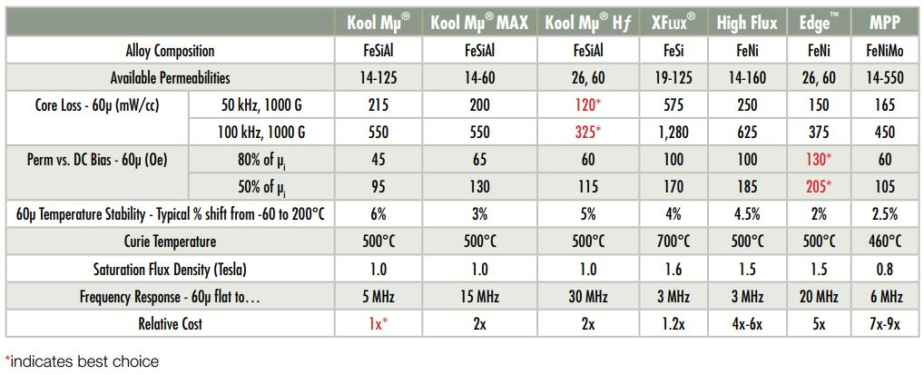

Figure 3 Classification of powder cores [2]

### Shape of Core

Common preference for flyback transformers is toroidal shape. The copper loss can be decreased with both toroidal shape and E shape according to the current situation. While toroidal shapes have permeability between 14μ-125μ, E shapes have maximum 90μ relative permeability. However, E shapes have relatively higher Ae, area. Also, the window area may be higher in toroids. Hence, toroidal shape is selected.

### Size of Core

Size of core will be determined from available manufactured cores. Cores are researched on [Magnetics](https://www.mag-inc.com/). Selected cores are tested whether they satisfy limitations due to inductance, flux density, saturation current, fill factor. The constructed GUI on MATLAB is used to test scores. Constructed GUI can be seen in Figure 4.

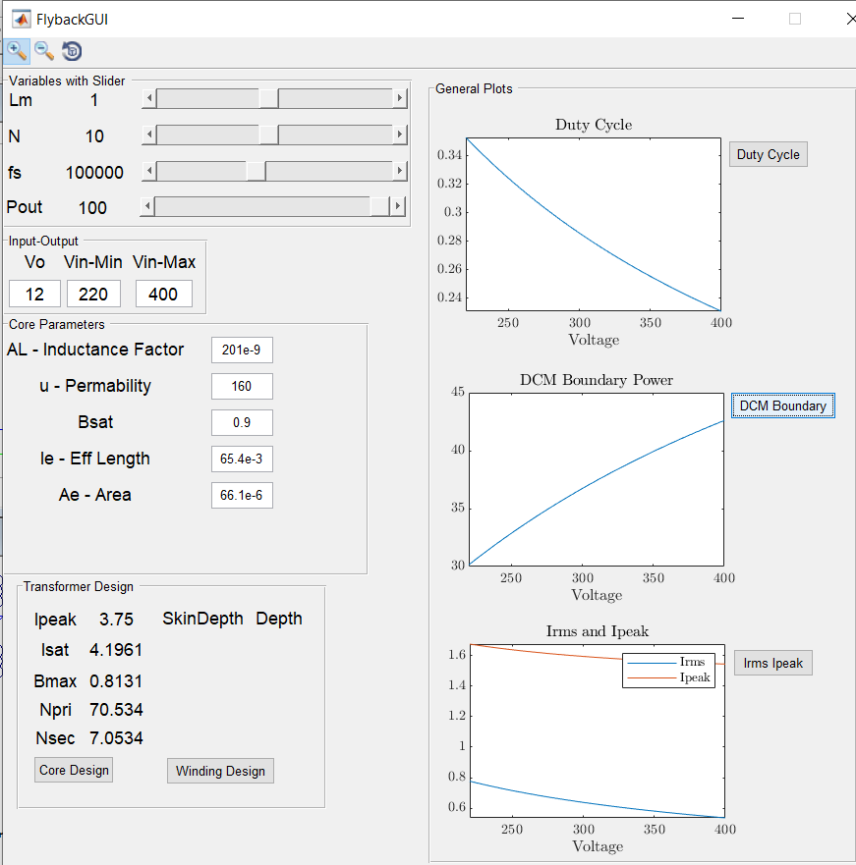

Figure 4 The constructed GUI on MATLAB for flyback converter design

Peak current value of the primary side is calculated ISW(MAX) that equals to 3.75A with safety margin. Safety margin is determined according to %80 efficiency of converter. The safety margin for saturation current of a core can be taken as %10, since the efficiency creates a sufficient safe region. Hence, minimum saturation current is 4.1A.

Kool Mu cores have 10,500 Gauss saturation level, which is approximately equal to 1 Tesla. Since the saturation current and created maximum flux density are proportional to each other, saturation can be checked from both created maximum flux density and peak current of the primary side.

Copper losses are also important due to AC resistance and number of windings. The optimization for copper losses based on core selection can be stimulated with selection of cores with high inductance factor, AL.

Equation (11) shows the calculation of saturation current and the created maximum flux.

|  |  |  |
| --- | --- | --- |
|  |  | (11) |

Table 3 shows the comparison of different cores. Table 3 shows the cores are in order from high volume to low volume. Core 3 is the most suitable one for required saturation limits. Hence, the core 3 is selected. Inductance factor would be more to decrease windings but there is no available Kool Mu core.

Table 3 Comparison Kool Mu cores in different sizes and inductance factors

|  |  |  |  |
| --- | --- | --- | --- |
| **Parameters** | **Core 1**  **930** | **Core 2**  **350** | **Core 3**  **310** |
| **Bsat (Tesla)** | 0.9 | 0.9 | 0.9 |
| **μ - Permeability** | 125 | 125 | 125 |
| **AL – Inductance factor(nH/T^2)** | 157 | 105 | 90 |
| **Le – eff length (mm)** | 63.5 | 58.8 | 56.7 |
| **Ae – Area (mm2)** | 65.4 | 38.8 | 31.7 |
| **Isat (A)** | 7.42 | 5.4 | 4.76 |
| **Bmax (Tesla)** | 0.47 | 0.62 | 0.69 |
| **Np (Turns)** | 50.5 | 61.7 | 66.7 |
| **Ns and Nthird (Turns)** | 6.3 | 7.7 | 8.3 |

## Winding and Fill Factor

Maximum switching frequency of the controller LT8316 is 140kHz. However, 140kHz switching is not observed at high load. LT8316 works in boundary mode for high load and as load increases, switching period should be increased according to Equation (8). Thus, AC resistance is not as much as higher at high load. Skin depth is relatively low at high voltage. Figure 5 given in datasheet also explains the case.

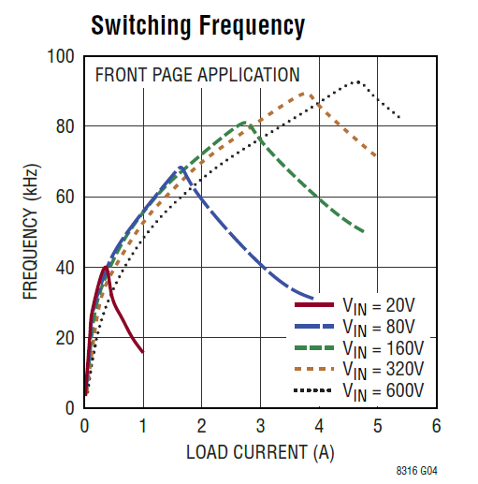

Figure 5 Switching frequency vs load, LT8316

Cable diameter should not be selected according to maximum switching frequency. The selection of cable according to maximum switching frequency may cause selection of cable having small area so that conduction losses at high load becomes high.

Even if the most reliable option to calculate AC resistances due to skin effect and proximity effect is finite element analysis, there are also other methods such as Dowell’s equation. These calculations will be done after simulation. Now, the skin depth is only calculated, and it can be seen in Equation (12). Output current equals 8.3A at full load, which results in approximately 60 kHz for 320V input. Hence, we can calculate the skin effect at 60kHz switching frequency. Besides, temperature of copper is assumed 80°C.

|  |  |  |
| --- | --- | --- |
|  |  | (12) |

When radius of a cable is selected as equal to skin depth, the whole area of the core can be used so that there will be no excessive cable thickness. As the frequency increases, AC resistance will increase. However, since the load will become less, copper loss can be negligible. AWG23 cable can be used for the primary side.

The current passing through the secondary side cable is eight times of the primary side current and the frequency is the same. At full load, secondary side should be capable to sink 8.3Adc, 11Arms. Since the ampacity of AWG23 for 75°C rating at 30°C ambient is approximately 5A, two parallel winding of AWG23 cable can be used. On the other hand, the tertiary winding can be wound with AWG30. Since the tertiary winding is solely used to get feedback, there is a very small current. Table 4 shows the windings details and fill factor.

Table 4 Transformer cable sizes and fill factor

|  |  |  |  |
| --- | --- | --- | --- |
|  | **AWG** | **# of Turns** | **Copper Area** |
| **Primary** | 23 | 67 | 17.3 mm2 |
| **Secondary** | 23 | 8.3 x2 | 4.3 mm2 |
| **Tertiary** | 30 | 8.3 | 0.83 mm2 |
| **Total** | NA | 92 | 22.43 mm2 |
| **Fill Factor** |  | | |

# Simulations

After finalizing the analytical calculations, the simulation model is constructed and simulated. For simulations we are using LTSpice since we have opted to use controllers manufactured by Analog Devices. LTSpice is a SPICE-based analog electronic circuit simulation software that is produced by the semiconductor manufacturer Analog Devices. It is the most widely used distribution of the SPICE software. Here the LTC3805 and LT8316 designs have been analyzed and the resulting waveforms have been taken. The efficiency report has been added for the LTC3805 design but could not be done for the LT8316. Though from the simulations we observed similar efficiency values for both.

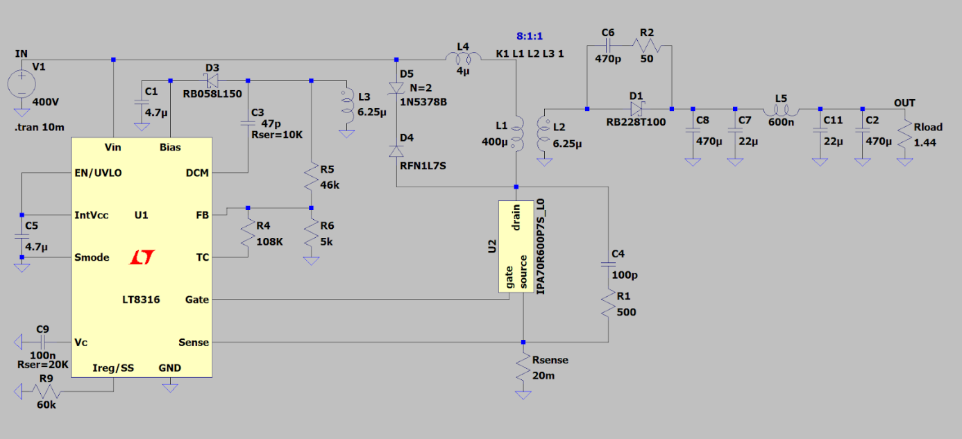

Figure 6 LTSpice schematic for the No Opto Flyback Converter (LT8316)

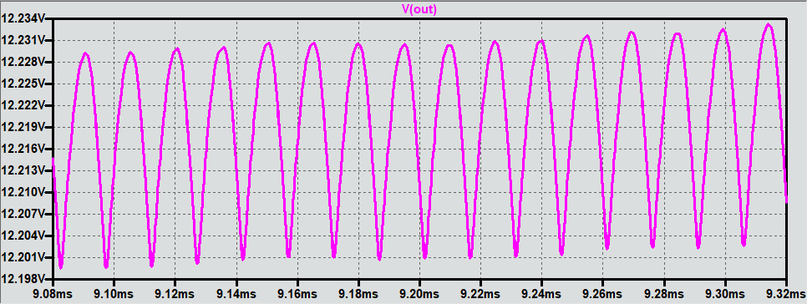

Figure 7 Output voltage of converter at full load and 400V input (LT8316)

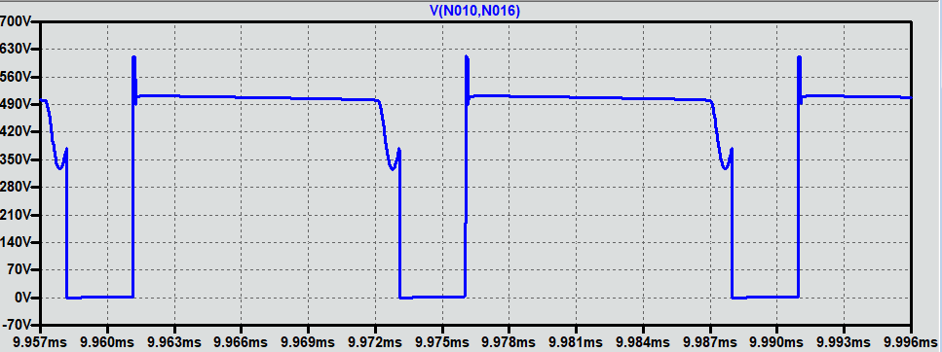

Figure 8 Voltage on the MOSFET at full load and 400V input (LT8316)

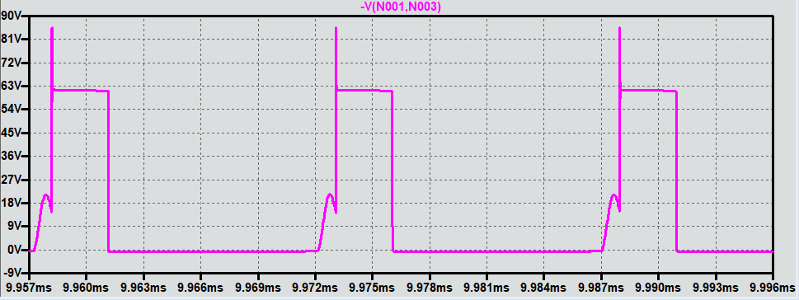

Figure 9 oltage on the Diode at full load and 400V input (LT8316)

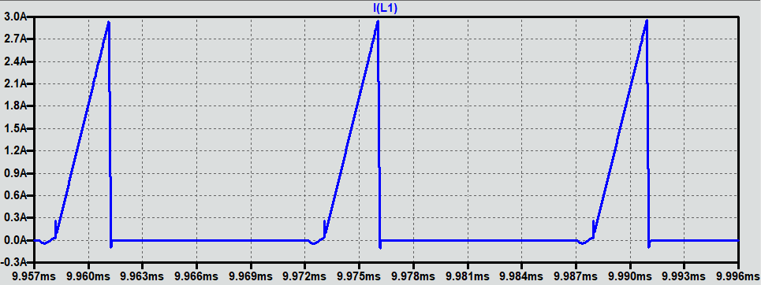

Figure 10 Current waveforms of the transformer’s primary at full load and 400V input (LT8316)

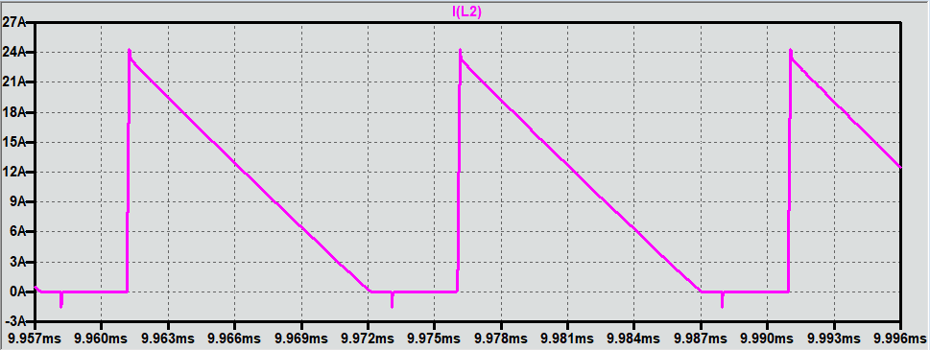

Figure 11 Current waveforms of the transformer’s secondary at full load and 400V input (LT8316)

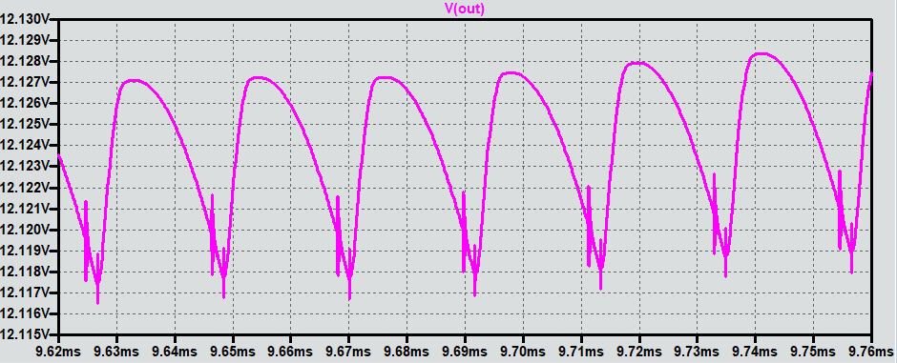

Figure 12 Output voltage of converter at 10% load and 220V input (LT8316)

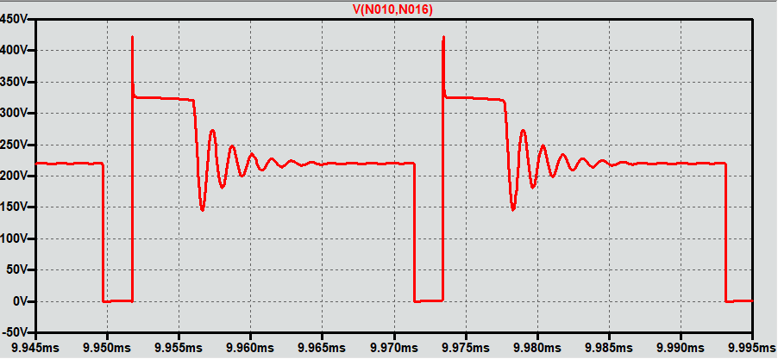

Figure 13 Voltage on the MOSFET at 10% load and 220V input (LT8316)

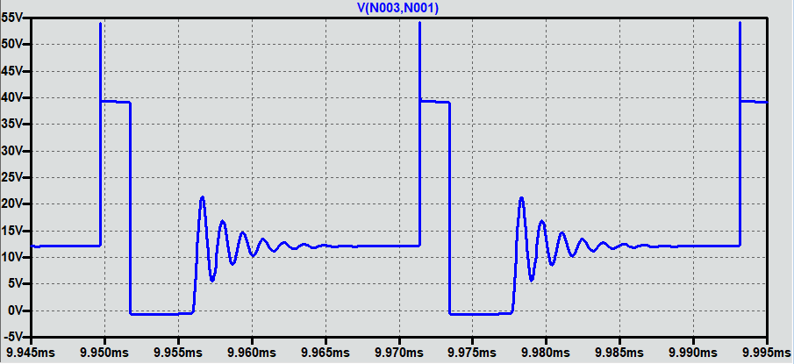

Figure 14 Voltage on the Diode at 10% load and 220V input (LT8316)

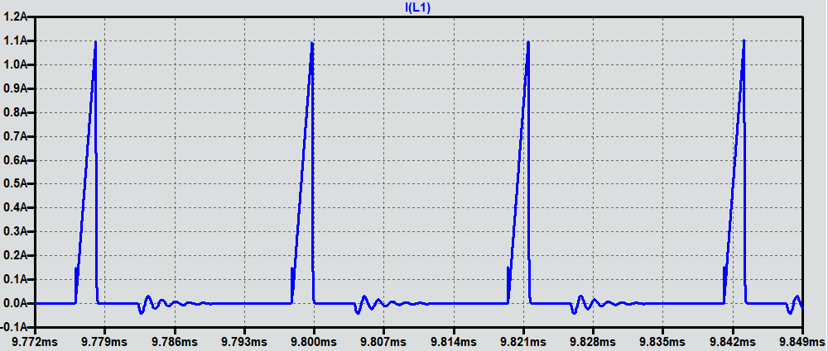

Figure 15 Current waveforms of the transformer’s primary at 10% load and 220V input (LT8316)

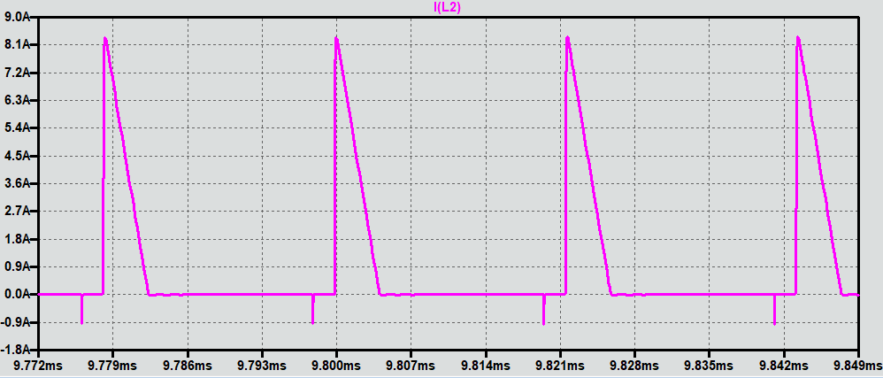

Figure 16 Current waveforms of the transformer’s secondary at 10% load and 220V input (LT8316)

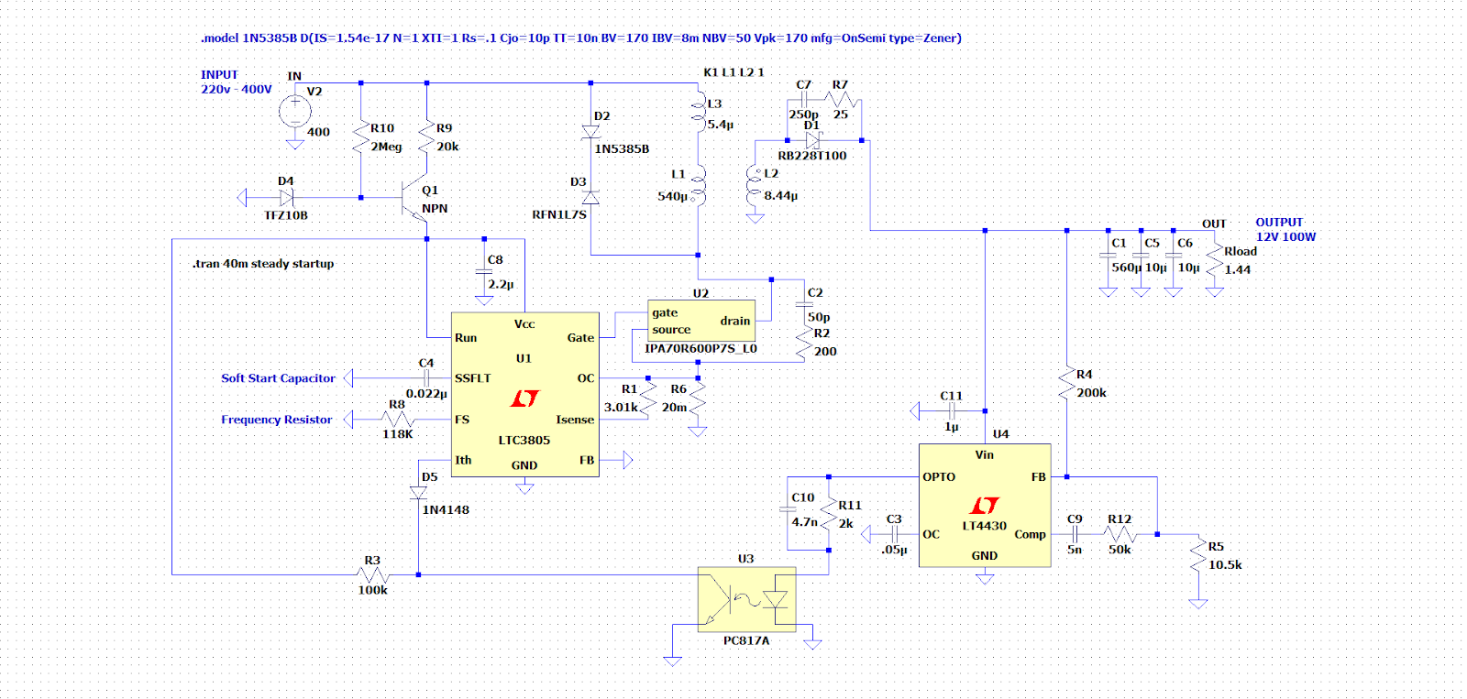

Figure 17 LTSpice schematic for the Flyback Converter with Opto (LTC3805)

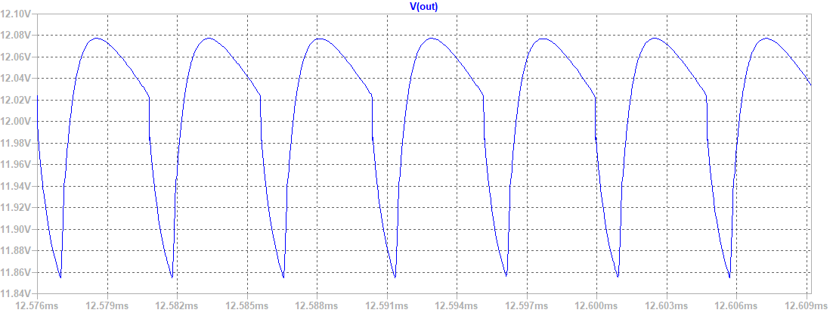

Figure 18 Output voltage of converter at full load and 400V input (LTC3805)

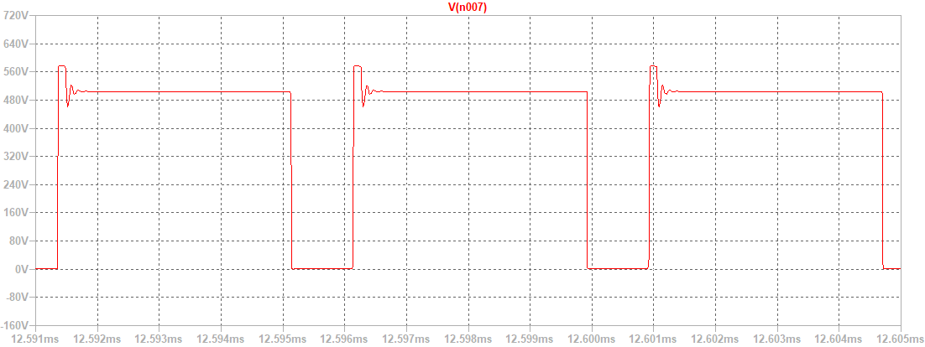

Figure 19 Voltage on the MOSFET at full load and 400V input (LTC3805)

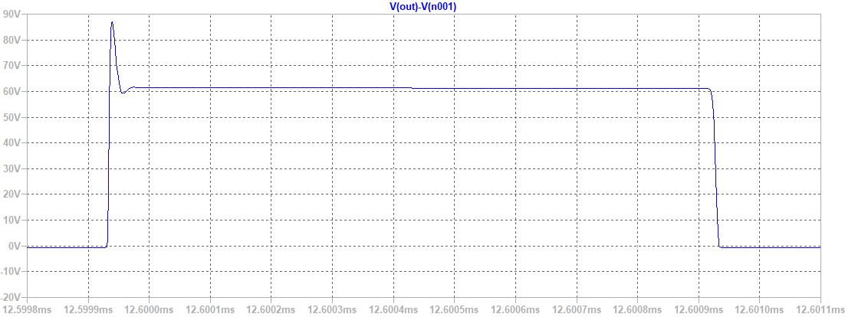

Figure 20 Voltage on the Diode at full load and 400V input (LTC3805)

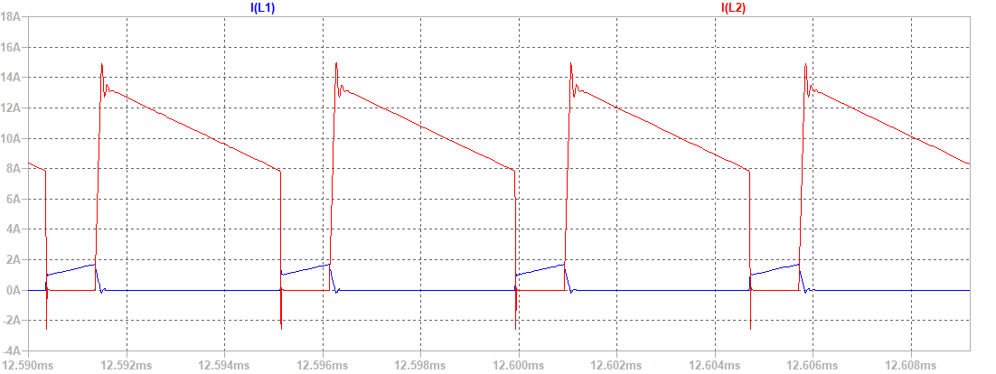

Figure 21 Current waveforms of the transformer’s primary and secondary at full load and 400V input (LTC3805)

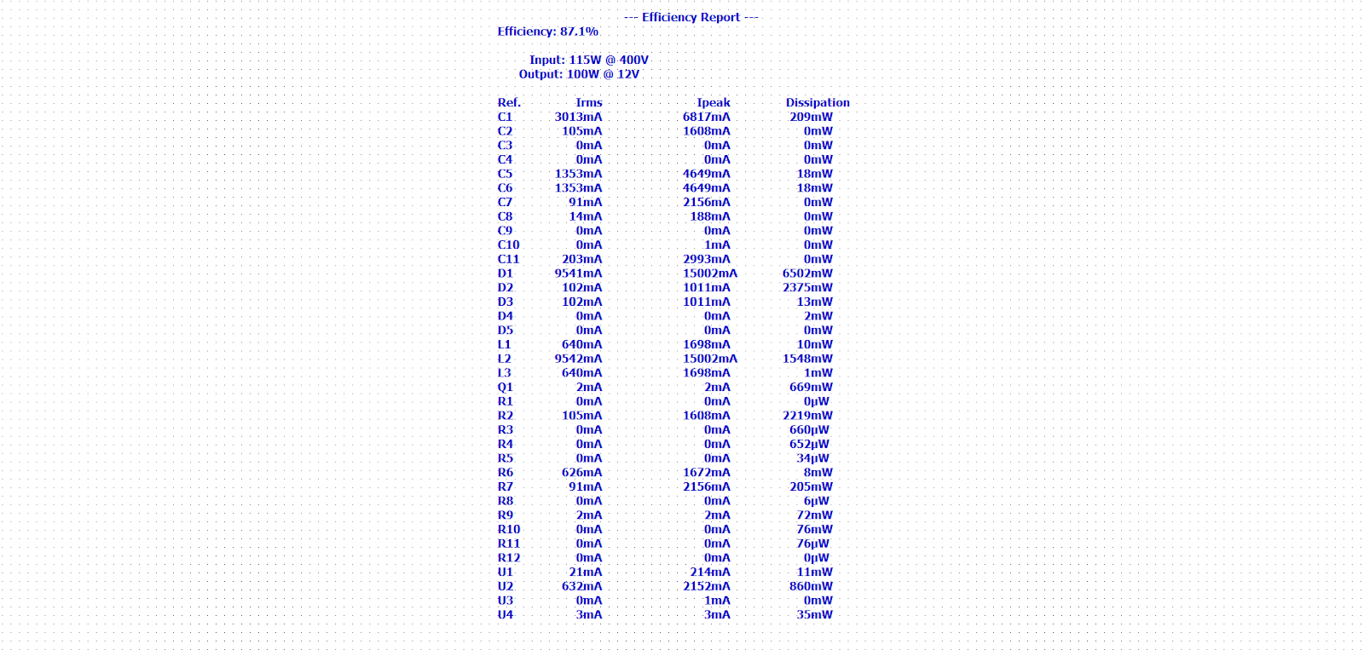

Figure 22 Efficiency report from LTSpice for the full load 400V input case (LTC3805)

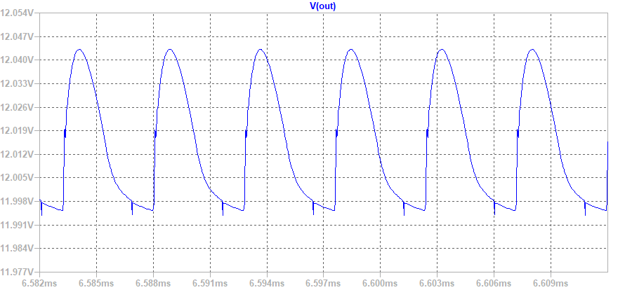

Figure 23 Output voltage of converter at 10% load and 220V input (LTC3805)

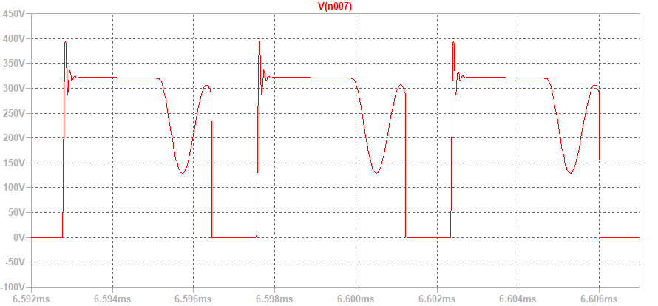

Figure 24 Voltage on the MOSFET at 10% load and 220V input (LTC3805)

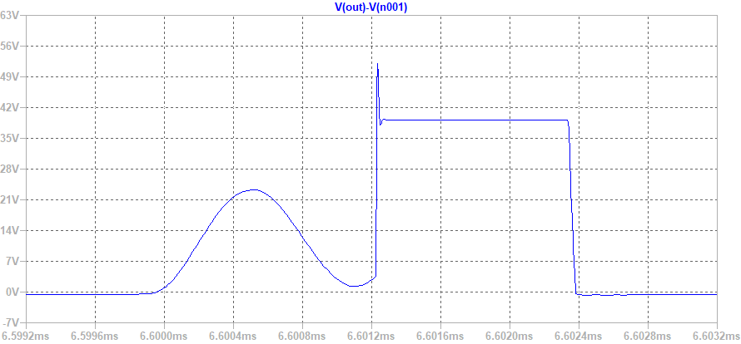

Figure 25 Voltage on the Diode at 10% load and 220V input (LTC3805)

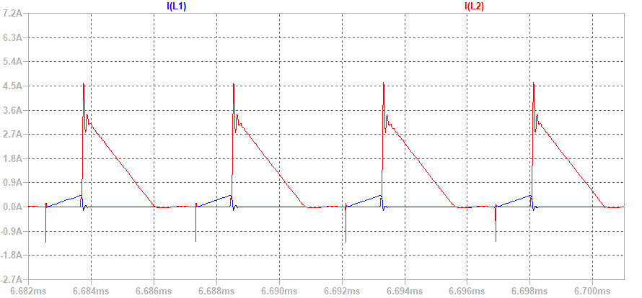

Figure 26 Current waveforms of the transformer’s primary and secondary at 10% load and 220V input (LTC3805)

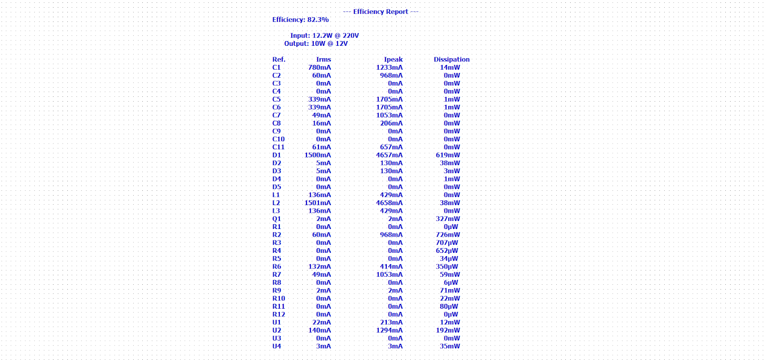

Figure 27 Efficiency report from LTSpice for the 10% load 220V input case (LTC3805)

Simulation results for both LTC3805 and LT8316 are given above. As seen in the results, both designs satisfy the project requirements for both full load and light load cases. However, LT8316 provides a simpler design.

# Component Selection

After simulating the circuit with LT8316, power components are selected. Although all the control and auxiliary components need to be selected at the end of the project, only the power components are considered yet. Because most of the cost and parasitic effects come from the power elements.

First, power MOSFET is selected according to the simulation results. At full load, peak voltage between drain and source terminals are approximately 630 V and peak current through the drain terminal is 3A. These values are considered while determining the ratings of the MOSFET. Controller IC can provide switching frequency up to 140kHz, which can create a high switching loss and thermal dissipation. By considering all the limitations above and adding some safety margin, IPA70R600P7S CoolMOS Power MOSFET is selected. Table below shows the ratings of this MOSFET. Detailed datasheet can be found in the Github repository.

Table 5 MOSFET parameters

|  |  |
| --- | --- |
| **VDS** | 700 V |
| **RDS(ON)** | 0.6 Ω |
| **ID,max** | 20 A |
| **Qg** | 10.5 nC |

Second, the secondary diode is selected. According to the simulation results, peak voltage on the diode is approximately 85V and peak current is approximately 25A. Since this diode can create a large switching loss, a schottky diode is preferred instead of a minority carrier diode. By considering these limitations, SS10PH9 Schottky diode which is manufactured by Vishay Semiconductor is selected. Table below shows the diode ratings.

Table 6 Diode Parameters

|  |  |
| --- | --- |
| **VR** | 100 V |
| **IF,average** | 10 A |
| **IF,peak** | 200 A |
| **VF** | 0.661 V |

After the switches, output capacitors are selected. There are two different types of capacitors at the output: 22uF and 470uF. Since the 22uF capacitors will most probably have a small ESR and be cheap, they will be selected later. For now, only the 470uF capacitors are selected. Output voltage is 12V. Capacitance and voltage ratings are considered with some safety margin while selecting the capacitors. Therefore, A750EQ477M1CAAE015 capacitors that are produced by KEMET are selected. Table below shows the ratings of these capacitors.

Table 7 Output Capacitor Ratings

|  |  |
| --- | --- |
| **VDC** | 16 V |
| **C** | 470 uF |
| **ESR @100kHz** | 15 mΩ |

Note that the LT8316 controls the circuit with variable frequency. As the switching frequency changes, impedances of capacitors may vary and for some high frequencies, they can even lose their capacitive characteristics and behave like a resistance or an inductor. To guarantee that the capacitors keep their characteristics, frequency analysis must be done. Most probably there will not be any problem. However, such an analysis is going to be conducted in the final report for reliability.

At the output of the converter, a CLC filter is used instead of a simple capacitor. For this filter, an inductor with 600nH inductance is required. According to the simulation results, peak current through this inductor is 24A and average current is 8.33A. These ratings are considered while selecting the inductor. ASPIAIG-F7030-R60 is chosen at the end. Table below shows the ratings of the inductor.

Table 8 Inductor Ratings

|  |  |
| --- | --- |
| L | 600 nH |
| **R** | 3.2 mΩ |
| **Saturation Current** | 32 A |
| **Temperature Rise Current** | 23 A |

To decrease the cost, the inductor may be designed instead of just buying it. This option will be considered after the feedback.

Finally, clamper circuit diodes are selected. Note that there is a schottky diode at the bias pin of the controller and snubbers for the MOSFET and secondary diodes. Since these parts face less stress than the ones are discussed here, they are selected in the future. In the clamper circuit, two zener (in series) and one normal diode are used. During the simulations, voltage and current stress on them are observed and selections are made according to the measurements. RFN1L7SSD is selected for the minority carrier diode and 1N5378B is selected for the zener diodes. Tables below show their ratings.

Table 9 Diode Ratings

|  |  |
| --- | --- |
| **Repetitive Peak Rev. Voltage** | 700 V |
| **Average Current** | 0.8 A |
| **Non-Rep. Surge Current** | 15 A |
| **Reverse Recovery Time** | 45 ns |

Table 10 Zener Diode Ratings

|  |  |
| --- | --- |
| **Zener Voltage** | 105 V |
| **Max. Steady State Power Dissipation** | 5 W |
| **Non-Rep. Surge Current** | 1.5 A |

After selecting some important components, a cost table is constructed to project the total cost and make changes in the elements if needed.

Table 11 Cost of Selected Components

|  |  |
| --- | --- |
| **Component** | **Unit Cost ($)** |
| *IPA70R600P7S CoolMOS Power MOSFET* | 1.03 |
| *SS10PH9 Schottky diode* | 0.39 |
| *A750EQ477M1CAAE015 Capacitor* | 0.15 |
| *ASPIAIG-F7030-R60 Inductor* | 0.86 |
| *RFN1L7SSD Diode* | 0.2 |
| *1N5378B Zener Diode* | 0.14 |
| *LT8316 Controller* | 3.345 |
| **Total** | 6.115 |

# Conclusion

Flyback topology is selected to implement isolated DC/DC converter from variable input voltage range (220V-400V) to 12V output with 100W output power. Advantages due to low size with single inductor and popularity are the parameters to select Flyback topology.

LT8316 is selected among some other alternative controllers such as PowiGan - InnoSwitch3-EP by Power Integrations, which is restricted by requirement of controller simulation. Since Analog Devices has LTSpice models of controllers, LT8316 is easily implemented on the simulation tool.

Determination of the topology and the controller have took us to design the transformer and clamp circuit, select semiconductor and output filter. Clamp circuits and semiconductor ratings depends on each other and they have been selected with that consideration. On the other hand, even if the transformer design have rule of thumbs and requirements, there is a huge gap for optimization in terms of core loss, copper loss and size. Thus, selection of turns ratio, primary inductance and winding have been explained in detail.

Finally, simulation report will be enhanced with further improvents on efficiency, thermal simulations and PCB design. Also, constructed GUI shown in Figure xxx will be used to optimize the converter in terms of efficiency, size and cost.

# References

[1] Analog Devices LT8316 Datasheet

<https://www.analog.com/media/en/technical-documentation/data-sheets/lt8316.pdf>

[2] Magnetics – Kool Mu cores properties

<https://www.mag-inc.com/Products/Powder-Cores>